CP-III Project Report on

**Smart Health Disease Prediction**

at

**U.V. Patel College of Engineering**



**Internal Guide Prepared By** Prof. Venus .R Patel 19012531010 Alay Patel

19012531014 Sani Patel

19012531016 Kashyap Raval

**B. Tech Semester VII**

**(Computer Engineering-AI)**

June 2022

Submitted to,

Department of Computer Engineering-AI

U.V. Patel College of Engineering

Ganpat University, Kherva - 384012

**U.V. PATEL COLLEGE**

**OF**

**ENGINEERING**



**22/11/2022**

**CERTIFICATE**

TO WHOM SO EVER IT MAY CONCERN

This is to certify that **Mr. Alay Patel** student of B.Tech. Semester VII (Computer Engineering-AI) has completed her/his full semester on site project work titled “**Smart Health Disease Prediction**” satisfactorily in partial fulfilment of the requirement of Bachelor of Technology degree of Computer Engineering-AI of Ganpat University, Kherva, Mehsana in the year 2022-2023.

College Project Guide Head, Computer Engineering-AI Sign

Prof. Venus .R Patel Dr. Paresh M. Solanki

**U.V. PATEL COLLEGE**

**OF**

**ENGINEERING**



**22/11/2022**

**CERTIFICATE**

TO WHOM SO EVER IT MAY CONCERN

This is to certify that **Mr. Kashyap Raval** student of B.Tech. Semester VII (Computer Engineering-AI) has completed her/his full semester on site project work titled “**Smart Health Disease Prediction**” satisfactorily in partial fulfilment of the requirement of Bachelor of Technology degree of Computer Engineering-AI of Ganpat University, Kherva, Mehsana in the year 2022-2023.

College Project Guide Head, Computer Engineering-AI Sign

Prof. Venus .R Patel Dr. Paresh M. Solanki

**U.V. PATEL COLLEGE**

**OF**

**ENGINEERING**



**22/11/2022**

**CERTIFICATE**

TO WHOM SO EVER IT MAY CONCERN

This is to certify that **Mr. Sani Patel** student of B.Tech. Semester VII (Computer Engineering-AI) has completed her/his full semester on site project work titled “**Smart Health Disease Prediction**” satisfactorily in partial fulfilment of the requirement of Bachelor of Technology degree of Computer Engineering-AI of Ganpat University, Kherva, Mehsana in the year 2022-2023.

College Project Guide Head, Computer Engineering-AI Sign

Prof. Venus .R Patel Dr. Paresh M. Solanki

# Acknowledgement

We sincerely feel the credit of the project work could not be narrowed down to only on individual. The development of this project involves many valuable contributions. Getting the opportunity for this project of “**Smart Health Disease Prediction**” as fulfilment of computer engineering-AI has been brightening experience for the near future to come and a focus on excellence in this venture, we are constantly guided and encouraged by **Prof. Venus .R Patel** who is our internal guide.

We would also thank our Head of the Department **Dr. Paresh M. Solanki for** giving us such a wonderful chance to work with this interesting project and perform the project work for the entire duration of the semester and also thanks to internal guide for project technical guidance and giving inspiration in all the way during project making. Finally, we would like to thank our parents, friends and almighty for being with us to support directly or indirectly while making this project.

**Thank you, sir**

# Abstract

Health Disease prediction is one of the largest field to research and its hard for normal human being to trust on AI based system. The Health Prediction system is an end user support and online consultation project. Here we propose a system that allows users to get instant guidance on their health issues through an intelligent health care system online. The system is fed with various symptoms and the disease/illness associated with those systems. The system allows user to share their symptoms and issues. It then processes user’s symptoms to check for various illnesses that could be associated with it. Here we use some intelligent data mining techniques to guess the most accurate illness that could be associated with patient’s symptoms. In doctor module when doctor login to the system doctor can view his patient details and the report of that patient. Doctor can view details about the patient search what patient searched for according to their prediction. Doctor can view his personal details. Admin can add new disease details by specifying the type and symptoms of the disease into the database. Based on the name of the disease and symptom the data mining algorithm works. Admin can view various disease and symptoms stored in database. This system will provide proper guidance when the user specifies the symptoms of his illness.

**Table of Contents**

Acknowledgement i

Abstract ii

List of Figure v

List of Tables vi

1. Introduction 1

1.1 Purpose 1

1.2 Project Scope 1

1.3 Problem Statement 2

1.4 Proposed System 2

1.5 Objective 2

2. Methodology 3

2.1 Tools and Technology 3

• Django 3

• CSS 3

• JavaScript 4

• Machine learning 4

• Python 5

3. Software Requirements Specification (SRS) 6

3.1 Feasibility Study 6

3.2 Hardware Requirements 6

3.3 System Overview 7

3.4 Project Planning 9

4. System Design 10

4.1 Activity Diagram 10

4.2 Sequence Diagram 11

4.3 ER Diagram 12

4.4 Use Case Diagram 14

4.5 Data Diagram 15

4.6 Data Dictionary 17

5. Implementation 18

5.1 View All Doctors Page 18

5.2 Admin Dashboard 18

5.3 View Prediction History Page 19

5.4 Input User Health Parameters Page 19

5.5 User Profile Page 20

5.6 User Dashboard 20

5.7 View Patients Detail 21

5.8 Signup Page 22

5.9 Login Page 23

6. Software Testing 24

6.1 Testing Plan 24

6.2 Testing Method Testing Method 24

6.3 Testing Cases 24

6.3.1 User 24

7. Advantages & Limitations 26

7.1 Advantages 26

7.2 Limitations 26

8. Conclusion & Future work 28

8.1 Conclusion 28

8.2 Future Work 28

9. Reference 29

# List of Figure

Fig 4. 1 Activity Diagram 10

Fig 4. 2 Administrator Sequence Diagram 11

Fig 4. 3 User Sequence Diagram 11

Fig 4. 4 ER diagram 13

Fig 4. 5 Use case Diagram of Admin 14

Fig 4. 6 Use case Diagram of Patient(User) 14

Fig 4. 7 Use case Diagram of Doctor(user) 15

Fig 4. 8 DFD level 0 16

Fig 4. 9 DFD level 1 17

Figure 5. 1 View All Doctors Page 18

Figure 5. 2 Admin Dashboard 18

Figure 5. 3 View Prediction History Page 19

Figure 5. 4 Input User Health Parameters Page 19

Figure 5. 5 User Profile Page 20

Figure 5. 6 User Dashboard 20

Figure 5. 7 View Patients Detail 21

Figure 5. 8 Signup Page 22

Figure 5. 9 Login Page 23

Fig 6.3 1 Test Cases 24

# List of Tables

Table 3. 1 Project Planning 9

Table 4. 1 Data Dictionary 17

# Introduction

It might have happened so many times that you or someone yours need doctors help immediately, but they are not available due to some reason. The Health Prediction system is an end user support and online consultation project. Here we propose a system that allows users to get instant guidance on their health issues through an intelligent health care system online. The system is fed with various symptoms and the disease/illness associated with those systems. The system allows user to share their symptoms and issues. It then processes user’s symptoms to check for various illnesses that could be associated with it. Here we use some intelligent data mining techniques to guess the most accurate illness that could be associated with patient’s symptoms. In doctor module when doctor login to the system doctor can view his patient details and the report of that patient. Doctor can view details about the patient search what patient searched for according to their prediction. Doctor can view his personal details. Admin can add new disease details by specifying the type and symptoms of the disease into the database. Based on the name of the disease and symptom the data mining algorithm works. Admin can view various disease and symptoms stored in database. This system will provide proper guidance when the user specifies the symptoms of his illness.

## Purpose

User can search for doctor’s help at any point of time. User can talk about their illness and get instant diagnosis. Informs the user about the type of disease or disorder it feels. Doctors get more clients online.

## Project Scope

The project has a wide scope, as it is not intended to a particular organization. This project is going to develop generic software, which can be applied by any healthcare organization. More over it provides facility to its users. Also the software is going to provide a huge amount of summary data.

## Problem Statement

Prediction of health disease may seem tricky, but this is part of user service system (application support direct contact with user).

## Proposed System

To beat the downside of existing framework we have created smart health disease prediction System. We have built up a specialist framework called Smart Health Prediction framework, which is utilized for improving the task of specialists. A framework checks a patient at initial level and proposes the possible diseases. It begins with getting some information about manifestations to the patient, in the event that the framework can distinguish the fitting sickness, at that point it proposes a specialist accessible to the patient in the closest conceivable territory. On the off chance that the framework isn't sufficiently sure, it asks few questions to the patients, still on the off chance that the framework isn't sure; at that point it will show a few tests to the patient. In light of accessible total data, the framework will demonstrate the result. Here we utilize some intelligent methods to figure the most precise disorder that could be associated with patient's appearances and dependent on the database of a couple of patients restorative record, calculation (Naïve Bayes) is connected for mapping the side effects with conceivable diseases.This framework improves undertaking of the specialists as well as helps the patients by giving vital help at a soonest organize conceivable.

## Objective

The objective of this project entitled “Smart health disease prediction using machine learning” is to provide a user friendly and easily understandable GUI to users to easily get instant guidance on their health issues through an intelligent health care system online. The main objective of the System is to predict disease according to symptoms and also suggest list of nearby doctors.

# Methodology

## Tools and Technology

In this project we have used Python Programming Language along with Navie Bayes classifier, SVM Model.

We used the following tools to implement the project -

HTML + CSS (for frontend)

Python + libraries such as Django (for backend)

Keras

TensorFlow

JavaScript

#### Django

Web framework defined for developing a web application which can be implemented on python.

#### CSS

Cascading Style Sheets (CSS) are a collection of rules we use to define and modify web pages. CSS are similar to styles in Word. CSS allow Web designers to have much more control over their pages look and layout. For instance, you could create a style that defines the body text to be Verdana, 10 point. Later on, you may easily change the body text to Times New Roman, 12 point by just changing the rule in the CSS. Instead of having to change the font on each page of your website, all you need to do is redefine the style on the style sheet, and it will instantly change on all of the pages that the style sheet has been applied to. With HTML styles, the font change would be applied to each instance of that font and have to be changed in each spot.

CSS can control the placement of text and objects on your pages as well as the look of those objects.

HTML information creates the objects (or gives objects meaning), but styles describe how the objects should appear. The HTML gives your page structure, while the CSS creates the “presentation”. An external CSS is really just a text file with a .css extension. These files can be created with Dreamweaver, a CSS editor, or even Notepad.

The best practice is to design your web page on paper first so you know where you will want to use styles on your page. Then you can create the styles and apply them to your page.

#### JavaScript

JavaScript is a programming language commonly used in web development. It was originally developed by Netscape as a means to add dynamic and interactive elements to websites. While JavaScript is influenced by Java, the syntax is more similar to C and is based on ECMAScript, a scripting language developed by Sun Microsystems.

JavaScript is a client-side scripting language, which means the source code is processed by the client's web browser rather than on the web server. This means JavaScript functions can run after a webpage has loaded without COMMUNICATING with the server. For example, a JavaScript function may check a web form before it is submitted to make sure all the required fields have been filled out. The JavaScript code can produce an error message before any information is actually transmitted to the server.

Like server-side scripting languages, such as PHP and ASP, JavaScript code can be inserted anywhere within the HTML of a webpage. However, only the output of server-side code is displayed in the HTML, while JavaScript code remains fully visible in the source of the webpage. It can also be referenced in a separate .JS file, which may also be viewed in a browser.

#### Machine learning

Machine learning is a growing technology which enables computers to learn automatically from past data. Machine learning uses various algorithms for building mathematical models and making predictions using historical data or information. Currently, it is being used for various tasks such as image recognition, speech recognition, email filtering, Facebook auto-tagging, recommender system, and many more.

#### Python

Python is a widely used general-purpose, high level programming language. It was initially designed by Guido van Rossum in 1991 and developed by Python Software Foundation. It was mainly developed for emphasis on code readability, and its syntax allows programmers to express concepts in fewer lines of code.

Python is a programming language that lets you work quickly and integrate systems more efficiently.

Python is dynamically typed and garbage-collected. It supports multiple programming paradigms, including procedural, object-oriented, and functional programming. Python is often described as a "batteries included" language due to its comprehensive standard library.

# Software Requirements Specification (SRS)

## **Feasibility Study**

Preliminary investigation examine project practicability, the chance the system are helpful to the organization. The most objective of the practicability study is to check the Technical, Operational and Economical practicability for adding new modules and debugging previous running system. All system is possible if they're unlimited resources and infinite time. There are unit aspects within the actability study portion of the preliminary investigation.

* **Technical feasibility:** It includes finding out technologies for the project, both hardware and software. For our project, system needs internet connection. While using our webapp, make sure you have a steady internet connection. It is also not an issue in this era where almost every home or office has Wi-Fi.
* **Operational feasibility:** It is the ease and simplicity of operation of proposed system. System does not require any special skill set for users to operate it. In fact, it is designed to be used by almost everyone.
* **Economic feasibility:** Here, we find the total cost and benefit of the proposed system over current system. For this project, the main cost is documentation cost. As far as maintenance is concerned, free of cost
* **Organizational feasibility:** This shows the management and organizational structure of the project. That won’t create any management issues and will increase the feasibility of the project.

## **Hardware Requirements**

The software is designed to be light-weighted so that it doesn’t be a burden on the machine running it. This system is being build keeping in mind the generally available hardware and software compatibility. Here are the minimum hardware and software requirement for our project.

**DEVELOPER-Side requirement:**

**Hardware**:

* Intel core i5 7th Generation.
* RAM 4GB or more.

**Software**:

* Windows 10(32-bit) or above.
* Python 3 or later.
* Django
* TensorFlow GPU
* OpenCV

**CLIENT-Side requirement:**

* Laptop or mobile phone with internet Connection

## **System Overview**

* + 1. **Patient Login: -** Patient Login to the system using his ID and Password.
    2. **Patient Registration: -**If Patient is a new user he will enter his personal details and he will user Id and password through which he can login to the system.
    3. **My Details: -** Patient can view his personal details.
    4. **Disease Prediction: -** Patient will specify the symptoms caused due to his illness. System will ask certain question regarding his illness and system predict the disease based on the symptoms specified by the patient and system will also suggest doctors based on the disease.
    5. **Search Doctor:-** Patient can search for doctor by specifying name, address or type.
    6. **Feedback:-**Patient will give feedback this will be reported to the admin.
    7. **Doctor Login: -** Doctor will access the system using his User ID and Password.
    8. **Patient Details:** Doctor can view patient’s personal details.
    9. **Notification:** Doctor will get notification how many people had accessed the system and what all are the diseases predicted by the system.
    10. **Admin Login:** Admin can login to the system using his ID and Password.
    11. **Add Doctor:** Admin can add new doctor details into the database.
    12. **Add Dataset:** Admin can add dataset file (which contains disease details along with symptoms) in database.
    13. **Add Disease:** Admin can add disease details along with symptoms and type.
    14. **View Doctor:** Admin can view various Doctors along with their personal details.
    15. **View Disease:** Admin can view various diseases details stored in database.
    16. **View Patient:** Admin can view various patient details who had accessed the system.
    17. **View Feedback:** Admin can view feedback provided by various users.

## **Project Planning**

Table 3. Project Planning

|  |  |  |  |
| --- | --- | --- | --- |
| Sr. No | Task To Complete | | Estimated Time |
| 1 | Project Initialization | | 1th Aug – 9th Aug |
| 2 | Documentation | | 10th Aug – 31th Sep |
| 3 | Requirements gathering | | 1st Sep – 6th Sep |
| 4 | Estimation and Scheduling | | 7th Sep – 17th September |
| 5 | Design Analysis | | 18th September 2022 – 8th November 2022 |
| 6 | | Validate and Update | 22th September 2022 – 8th November 2022 |
| 7 | | Development | 22th September 2022 – 8th November 2022 |
| 8 | | Testing and Validation | 22th September 2022 – 8th November 2022 |

# System Design



## Activity Diagram

An activity diagram illustrates the dynamic nature of a system by modeling the flow of management from activity to activity. An activity represents AN operation on some category within the system that leads to an amendment within the state of the system. Typically, activity diagrams are accustomed model progress or business processes and internal operation. As a result of AN activity diagram may be a special quite state chart diagram, it uses a number of constant modelling conventions.

Fig 4. Activity Diagram

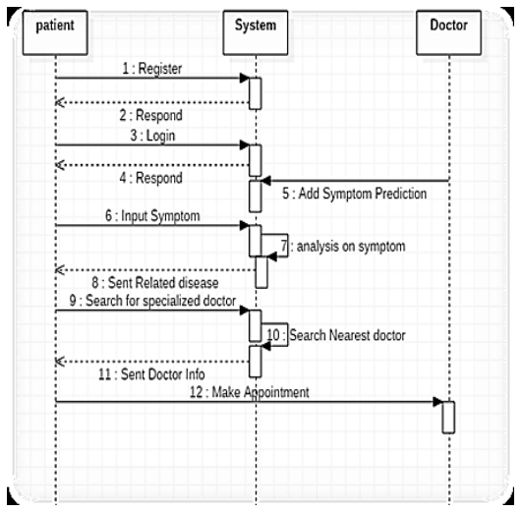

## Sequence Diagram

Fig 4. Administrator Sequence Diagram

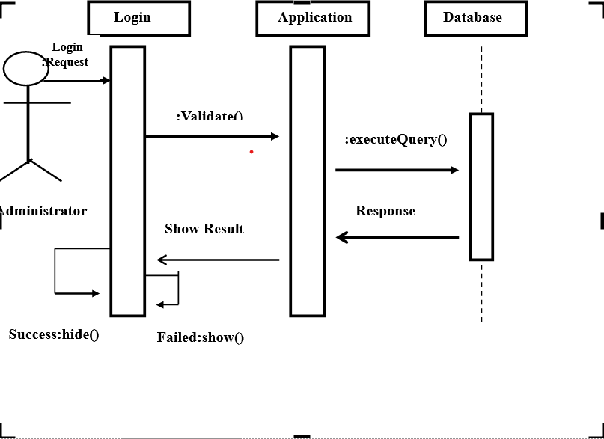

Fig 4. User Sequence Diagram

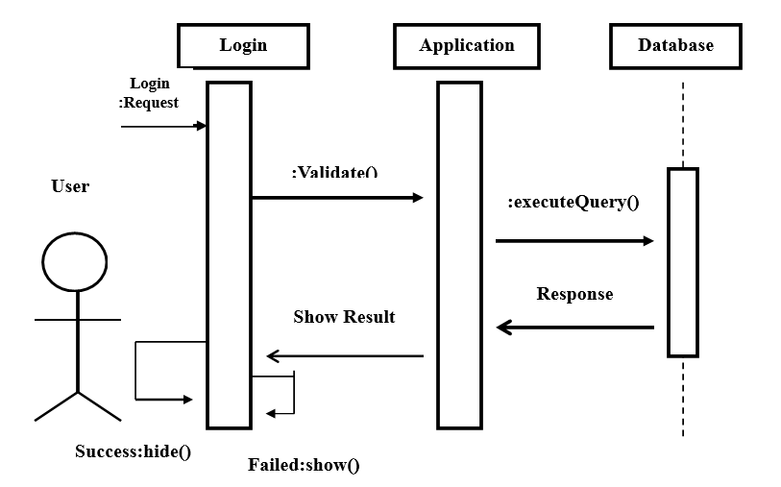

## ER Diagram

An entity-relationship (ER) diagram is a specialized graphic that illustrates the interrelationships between entities in a database. ER diagrams often use symbols to represent three different types of information. Boxes are commonly used to represent entities. Diamonds are normally used to represent relationships and ovals are used to represent attributes

An entity-relationship model (ERM) in software engineering is an abstract and conceptual representation of data. Entity-relationship modeling is a relational schema database modeling method, used to produce a type of conceptual schema or semantic data model of a system, often a relational database, and its requirements in a top-down fashion.

Symbols used in this E-R Diagram:

**Entity**: Entity is a “thing” in the real world with an independent existence. An entity may be an object with a physical existence such as person, car or employee. Entity symbol is as follows

**Attribute**: Attribute is a particular property that describes the entity. Attribute symbol is

**Relationship**: Relationship will be several implicit relationships among various entity types whenever an attribute of one entity refers to another entity type some relationship exits. Relationship symbol is:

Key attributes: An entity type usually has an attribute whose values are distinct for each individual entity in the collection. Such an attribute is called key attribute.

Fig 4. ER diagram

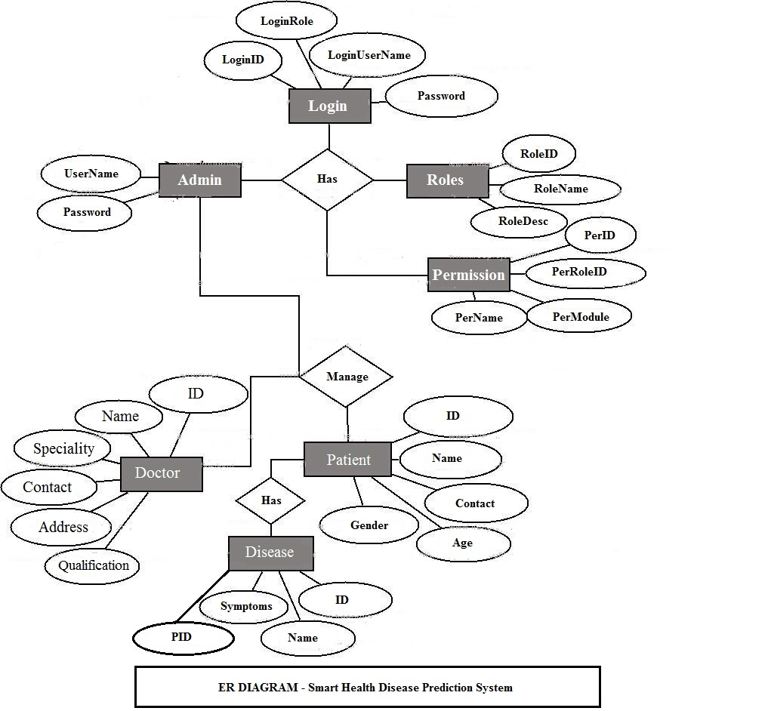

## Use Case Diagram

Fig 4. Use case Diagram of Admin

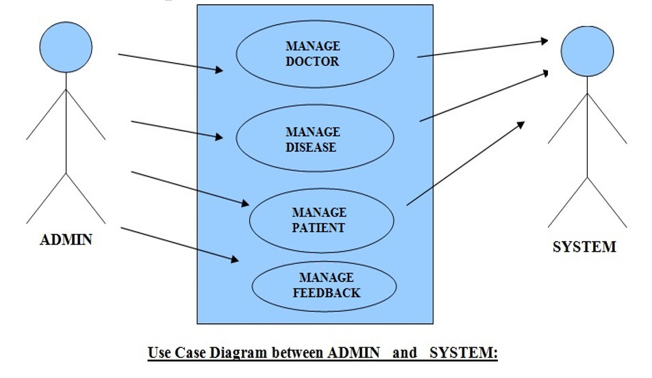

Fig 4. Use case Diagram of Patient(User)

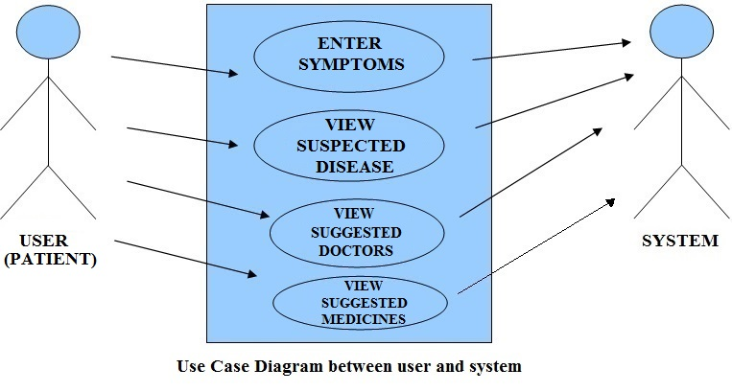

Fig 4. Use case Diagram of Doctor(user)

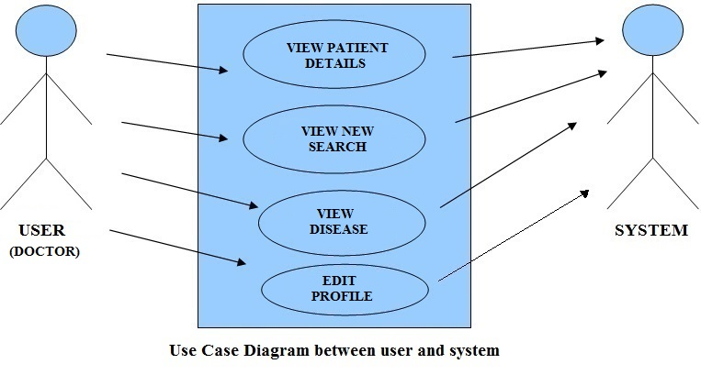

## Data Diagram

A Data Flow Diagram (DFD) is a graphical representation of the "flow" of data through an Information System. A data flow diagram can also be used for the visualization of Data Processing. It is common practice for a designer to draw a context-level DFD first which shows the interaction between the system and outside entities. This context-level DFD is then "exploded" to show more detail of the system being modeled.

A DFD represents flow of data through a system. Data flow diagrams are commonly used during problem analysis. It views a system as a function that transforms the input into desired output. A DFD shows movement of data through the different transformations or processes in the system.

Dataflow diagrams can be used to provide the end user with a physical idea of where the data they input ultimately has an effect upon the structure of the whole system from order to dispatch to restock how any system is developed can be determined through a dataflow diagram. The appropriate register saved in database and maintained by appropriate authorities.

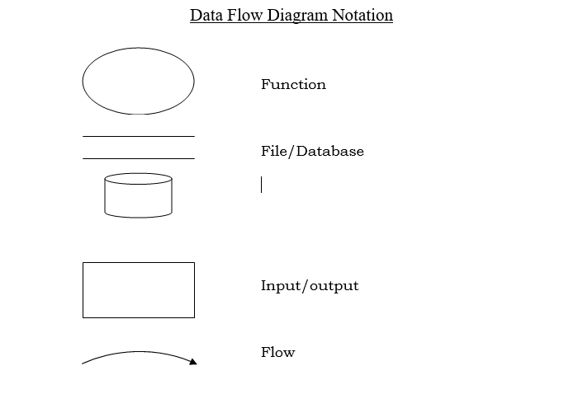

Fig 4. DFD level 0

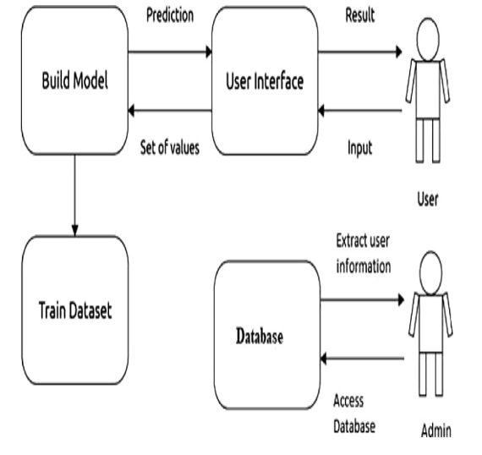

Fig 4. DFD level 1

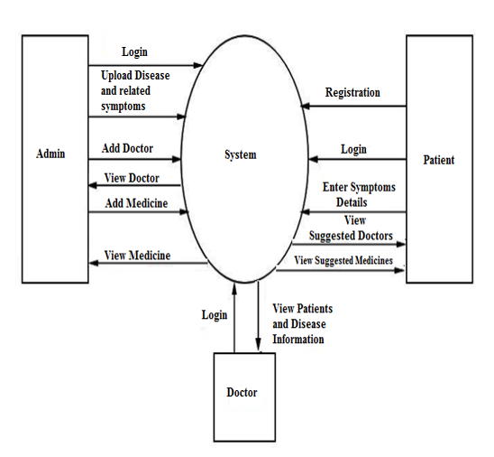

## Data Dictionary

Table 4. Data Dictionary

|  |  |  |  |  |
| --- | --- | --- | --- | --- |
| name | datatype | length | constraint | description |
| user_id | INT | 10 | Primary key | User id  Auto Generate |
| username | VARCHAR | 20 | Not Null | Name of user |
| password | VARCHAR2 | 30 | Not Null | Login password for user |

# Implementation

## View All Doctors Page

Figure 5. View All Doctors Page

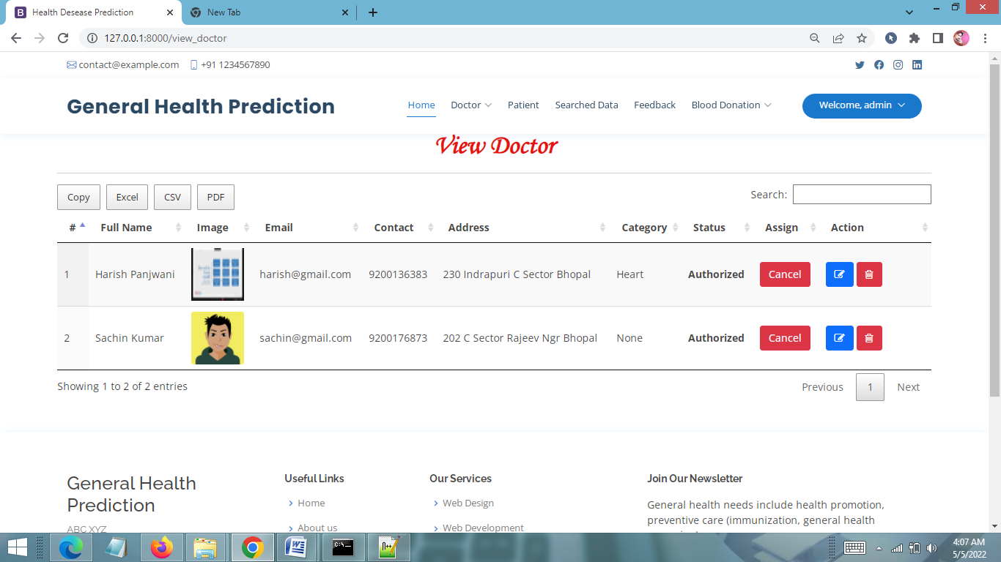

## Admin Dashboard

Figure 5. Admin Dashboard

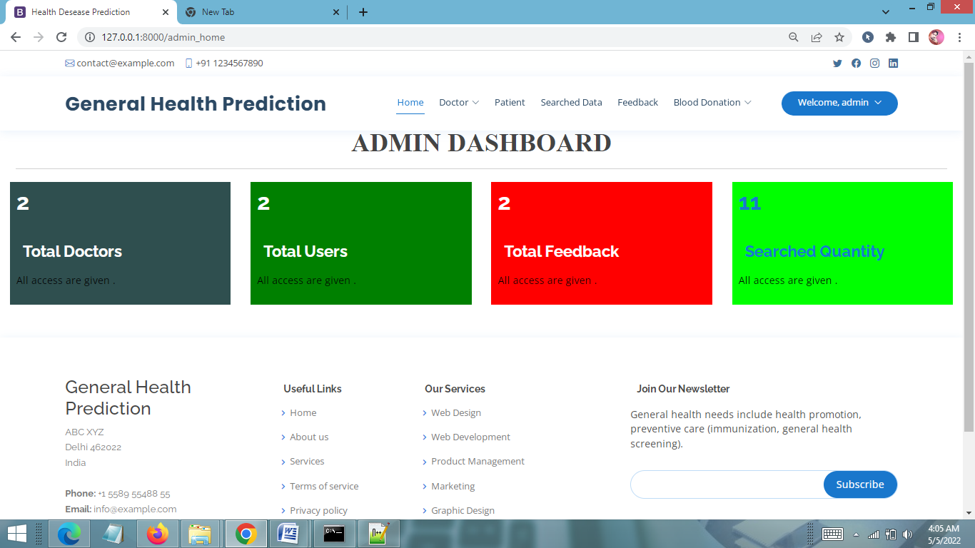

## View Prediction History Page

Figure 5. View Prediction History Page

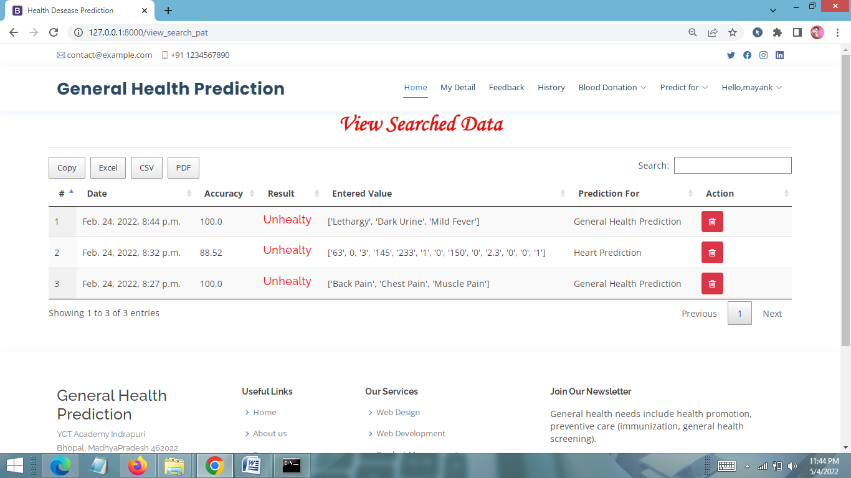

## Input User Health Parameters Page

Figure 5. Input User Health Parameters Page

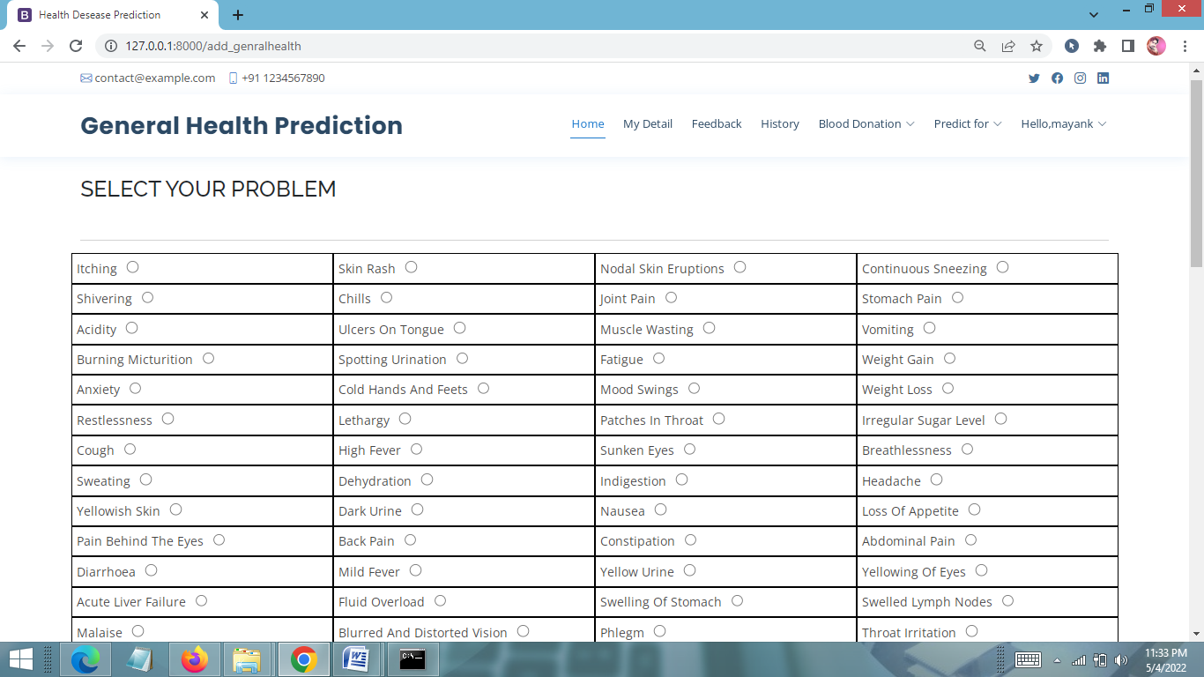

## User Profile Page

Figure 5. User Profile Page

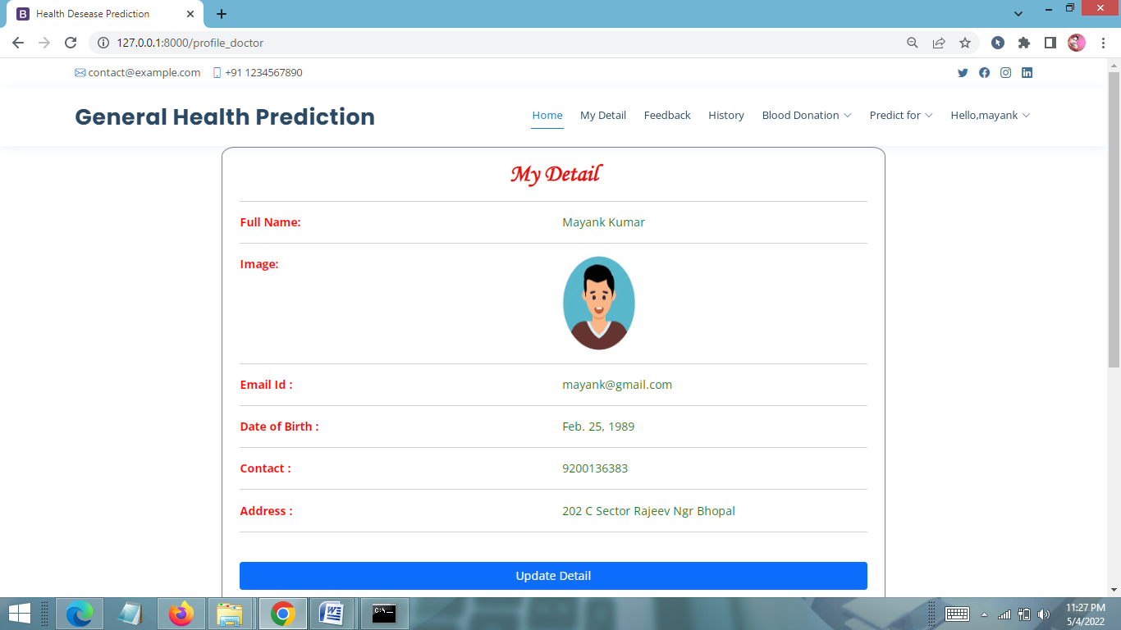

## User Dashboard

Figure 5. User Dashboard

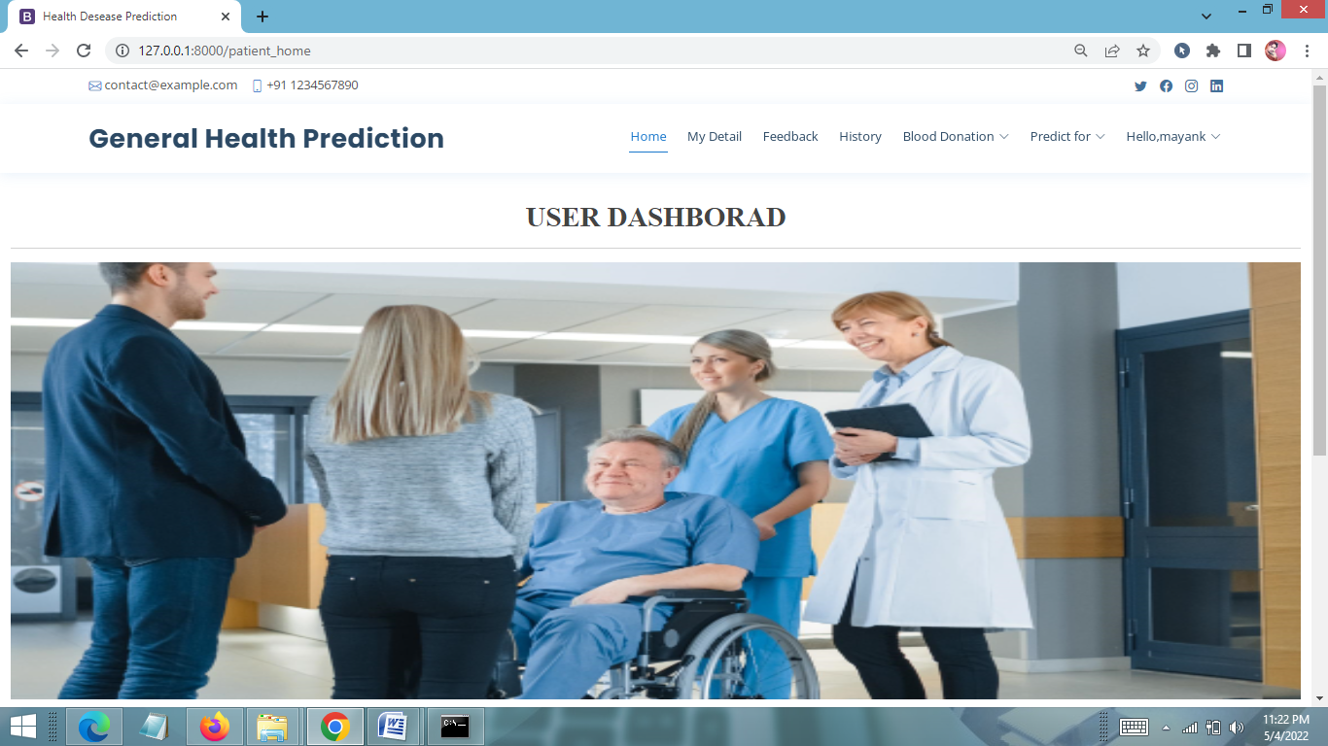

## View Patients Detail

Figure 5. View Patients Detail

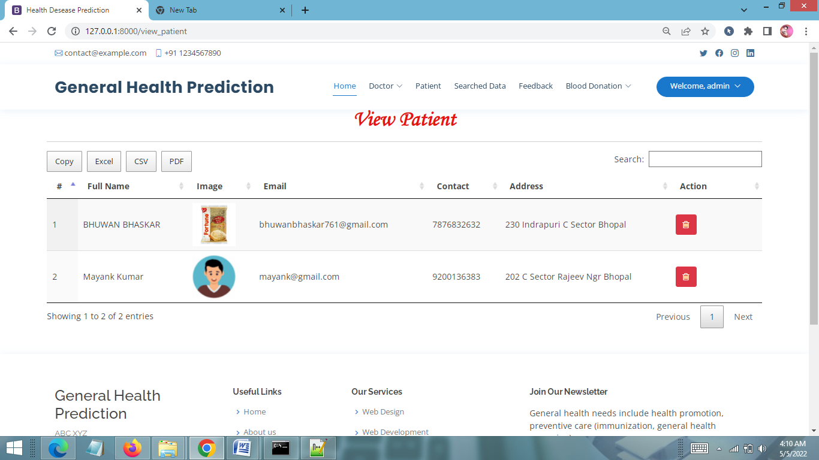

## Signup Page

Figure 5. Signup Page

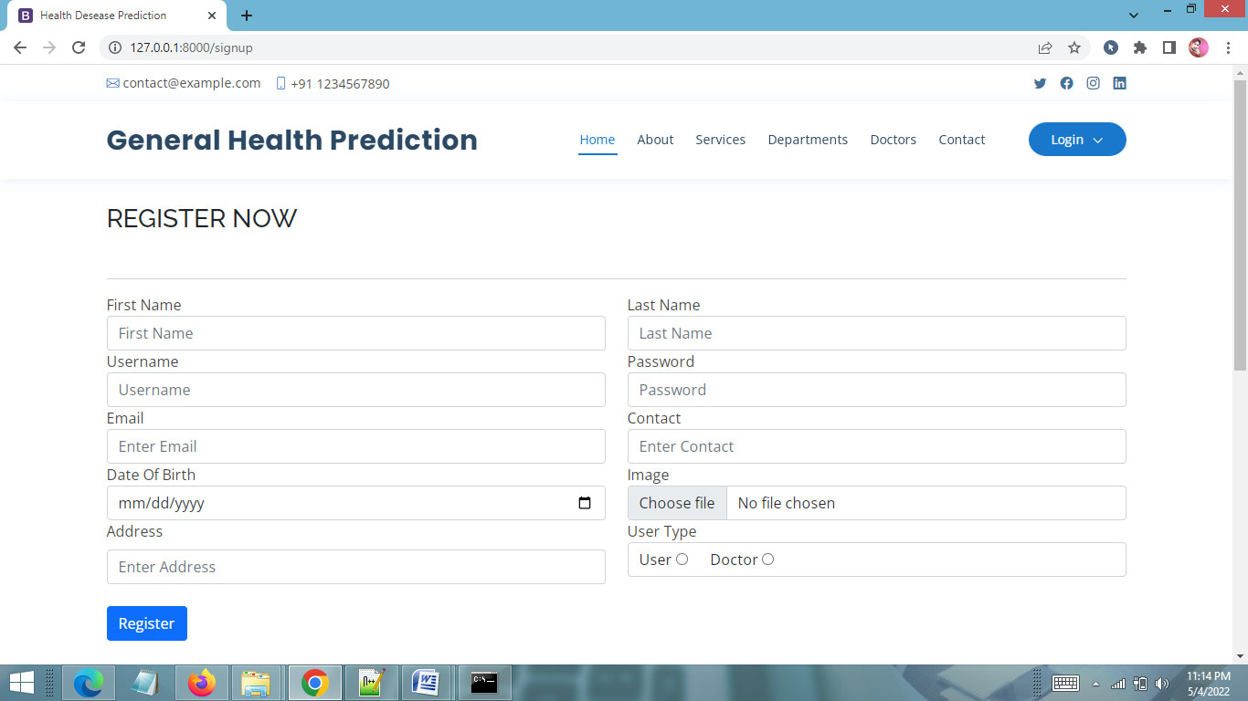

## Login Page

Figure 5. Login Page

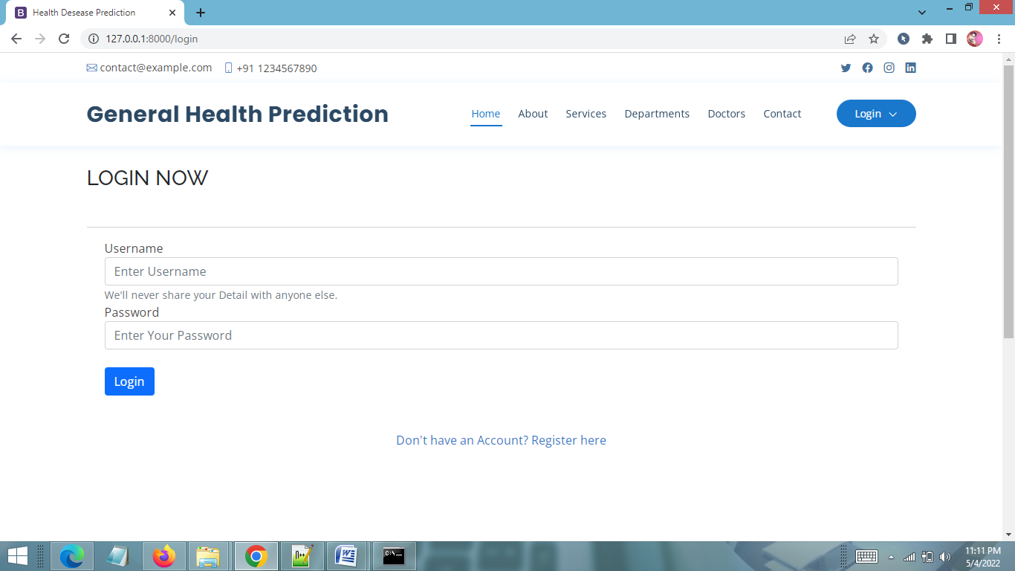

# Software Testing

Software testing is a process of running with intent of finding errors in software. Software testing assures the quality of software and represents final review of other phases of software like specification, design, code generation etc

## Testing Plan

A Test Plan is a detailed document that describes the test strategy, objectives, schedule, estimation, deliverables, and resources required to perform testing for a software product. Test Plan helps us determine the effort needed to validate the quality of the application under test. The test plan serves as a blueprint to conduct software testing activities as a defined process, which is minutely monitored and controlled by the test manager. This system follows a coding and testing strategy for every small change for those particular changes and after completion of coding the system gets tested for the last time

## Testing Method Testing Method

In testing methods, we are going with unit testing in which system is tested unified. That means each and every component added to the system is going to be tested whenever it will be added to the system for the first time before final release.

## Testing Cases

Here is the list of test cases which is covered by unified testing models.

### User

Fig 6.3 Test Cases

|  |  |
| --- | --- |
| **Purpose** | **Result** |
| Verify if a user will be able to login with a valid username and valid password. | Pass |
| Verify if a user cannot login with a valid username and an invalid password | Pass |
| Verify if a user can logout | Pass |
| Verify the messages for invalid login | Pass |
| Verify if the data in password field is either VIsible as asterisk or bullet signs | Pass |
| Verify if error page is shown | Fail |
| Verify if home pages shown after successful login | Pass |
| Verify if user can click on all the “try this” button | Pass |
| Verify if user validated by an email | Fail |
| Verify if user can upload image | Pass |
| Verify if user upload image with wrong format get error message | Fail |
| Verify if user able to download image | Pass |
| Verify if user able to get desire output | Pass |
| Verify if user use Smart Health Disease Prediction | Pass |

# Advantages & Limitations

### Advantages

“Smart Health Prediction System” provides various features, which complement the information system and increase the productivity of the system. These features make the system easily usable and convenient. Some of the important features included are listed as follows:

1. Intelligent User Forms Design
2. Data access and manipulation through same forms
3. Access to most required information
4. Data Security
5. Restrictive data access, as per login assigned only.
6. Organized and structured storage of facts.
7. Strategic Planning made easy.
8. No decay of old Records.
9. Exact financial position of the Business.
10. User can search for doctor’s help at any point of time.
11. User can talk about their illness and get instant diagnosis.
12. Doctors get more clients online.

### Limitations

Besides the above achievements and the successful completion of the project, we still feel the project has some limitations, listed as below:

* It is not a large scale system.
* Only limited information provided by this system.
* Since it is an online project, users need internet connection.
* People who are not familiar with computers can’t use this software.
* The system is not fully automated; it needs doctors for full diagnosis.

# Conclusion & Future work

## Conclusion

It has been a great pleasure for me to work on this exciting and challenging project. This project proved good for me as it provided practical knowledge of not only programming in Python and Sqlite web based application. It also provides knowledge about the latest technology used in developing web enabled application and client server technology that will be great demand in future. This will provide better opportunities and guidance in future in developing projects independently.

## Future Work

Concealed learning will be extracted from the verifiable information in the proposed framework, by getting ready datasets by applying apriori calculation. Anticipating savvy wellbeing should be possible just if framework reacts that way. These datasets will be contrasted and the approaching questions and the last report will be produced utilizing Association Rule Mining. Since this proposed system will chip away at genuine chronicled information, it will give exact and productive outcomes, which will enable patients, to get the conclusion in a split second. More work should be possible later on by utilizing more informational index identified with heart sicknesses and by utilizing diverse information decrease techniques to improve the characterization. For better precision and expectation of heart sicknesses the datasets that will be used must be quality organized and free from special cases, inconsistencies, and missing characteristics. This web application can be additionally upgraded in an Android application. This will be accessible to clients on versatile premise and its utilization can be additionally expanded. Likewise, highlight like getting the specialist online on a visit with the goal that patients can straightforwardly converse with the concerned specialists. The modules doing malignant growth examination can be coordinated to discover how close the individual related with disease is. This will make this web application unsurprising in obvious sense.

# Reference

* Two scoops of Django for 1.11 by Daniel Greenfeld’s and Audrey Greenfield Lightweight Django by Elman and Mark Lavin Hands-on ML with Scikit-Learn, Keras & TensorFlow